**The Pi Lite – A Plug & Play LED Matrix Board for the Raspberry PI**

The Pi-Lite is a versatile, plug and play 126 LED (9x14 Grid), matrix display for the Raspberry Pi. Each pixel is individually addressable, so you can display scrolling text, graphics and bar graphs; basically anything that can fit in 126 pixels! It’s a great starting place for doing something visual with your Raspberry Pi.

The Pi-Lite comes as a complete, fully assembled board that requires no soldering, and it’s designed to plug straight into the Raspberry Pi’s GPIO ports. The matrix is controlled by an on-board ATmega 328 processor with pre-loaded software and works equally well with a Raspberry Pi using GPIO, or PC, Mac or Linux machine via the on-board FTDI connector. You’ll find a short beginner’s guide to set up on the Raspberry Pi below!

**Step 1. Setting up the Raspberry Pi for Basic Pi-Lite Functions!**

The Pi Lite is as Ciseco product, so requires a custom Wheezy Image to be loaded onto an SD card and used for this task. This image has reconfigured GPIO pins for Serial access, and the Minicom terminal emulator that’s used to send and receive characters from the serial port pre-installed. You can set all this up manually on your version of Raspian; however for ease of this tutorial, we’ll use the custom image which can be downloaded:

***http://openmicros.org/Download/2013-05-25-wheezy-raspbian-ciseco.img.zip***

Simply unzip the image and load it to an SD card like the standard Raspian distribution.

**Step 2. The Fun Stuff!**

Make sure your Raspberry Pi is switched off, and then plug the Pi Lite in. It sits on top of the GPIO ports within the footprint of the Pi, and fits neatly inside the ModMyPi Raspberry Pi Case. Boot your Pi up, log in and you’ll be presented with the Raspberry Pi Command Line. The Pi Lite will auto-boot with a very cool sequence too!

To access the Pi Lite module via Minicom and send scrolling text messages, enter the command:

***minicom -b 9600 -o -D /dev/ttyAMA0***

Now, simply by typing, you can send any text to the Pi Lite which will be scrolled across automatically. It’s also possible to enter Minicom’s command mode to change various settings, such as the scroll speed or pixel state.

To enter command mode type ***$$$*** (Three dollar signs) which will stop all scrolling, and Minicom responds with “OK”. All commands must be sent as one string in UPPER case, and terminated with carriage return (pressing enter). After receiving and carrying out a command, the Pi-Lite leaves command mode, and returns to scroll mode. If a command is not received within a few seconds or a command is inputted incorrectly, the command control will be terminated and the Pi Lite will return to scroll mode.

As an example, we’ll increase the scrolling speed using the SPEED command. By default, the scroll speed is set to 80, but it can be set anywhere from 1 (very fast) to 1000 (very slow). Let’s slow our scroll speed - Simply type:

$$$SPEED200

Then hit enter. The Pi Lite will automatically exit command mode and re-enter scroll mode. You can now check to see that you’re scroll speed has increased!

There’s a full list of commands, and the example scripts utilised in **Step 3** available at the following link. You’ll need these to show bar graphs, turn on/off individual pixels, and generally make your Pi Lite function:

***https://www.modmypi.com/pi-lite-raspberry-pi-led-matrix***

**Step 3. Running Scripts!**

What’s great about the Pi Lite, is that it enables you to run custom Python scripts, and subsequently show graphics, repeated text strings, read the Weather, run a real-time Twitter feed or display anything else you can imagine! I’ll show you how to download and run some example Python scripts, but you can always edit them or write your own if you’re feeling adventurous! Please note, use upper case in the commands where stated!

The Ciseco Wheezy Image will already have a suitable version of Python installed. However, you’ll also need to install the “Git Control System” and the “Python Serial Package”:

***sudo apt-get install git***

***sudo apt-get install python-serial***

We now need to pull the library files from Github and put them in a directory. First ensure you are in your home directory by changing directory to the standard home location:

***cd /home/pi***

Then create a directory for the Github example files, and browse to it:

***mkdir git***

***cd git***

Now obtain the Pi-Lite source code. This includes the python examples:

***git clone git://github.com/CisecoPlc/PiLite.git***

You can now browse to the example scripts:

***cd PiLite/Python_Examples***

Some of the scripts can be run straight from the command line via Python (CTRL+C will terminate). For this example, we’ll run the Pacman example script, which displays, you guessed it – Pacman!:

***python Pacman.py***

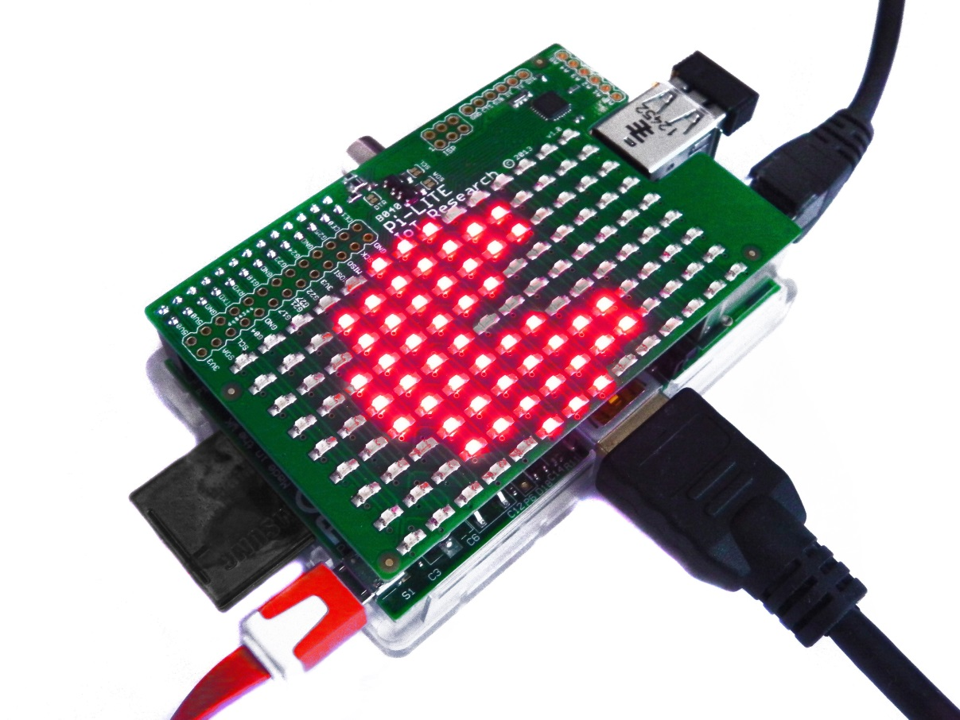

As with all Raspberry Pi projects, the best way to learn is to play, and a great place to start is the Pi Lite!

This article is sponsored by ModMyPi www.modmypi.com

All breakout boards and accessories used in this tutorial are available for Worldwide shipping from the ModMyPi Webshop.